Semma, Irshad! "Automation" dhaan oru Data Analyst-oda final weapon. Manual-a daily run pannama, computer-e automatic-a velai seiura maari pannuvom.
🤖 Class 5: Automating Your Analysis
Namma ippo panra automation-ku "Task Scheduler" (Windows-la) illa Python-la irukkura schedule library-ai use pannalam. Aana, simple-a irukka namma Windows Task Scheduler-ai use pannuvom.
1. The Strategy:
- python_script.py: Namma code-ai file-a maathittom.
- Batch File (.bat): Ithu oru "Mini-Robot". Ithu irundha, namma code-ai ore click-la run pannalam.
- Task Scheduler: Idhu oru "Alarm Clock". Idhu daily 9:00 AM-kku antha Batch file-ai trigger pannum.
2. Let's create the "Mini-Robot" (Batch File):
Open your Notepad, copy this, and save it as run_report.bat:
Code snippet
@echo off
cd C:\Python\PythonProject1
"D:\Python\PythonProject1\.venv\Scripts\python.exe" "Automated Salary Dashboard.py"
pause
- @echo off: Terminal-la unwanted text-ai hide panna.
- cd: Namma project folder-kku pogum.
- python.exe: Python-ai start panni namma file-ai run pannum.
🔍 Concept Breakdown:
- Batch File: Ithu oru list of commands. Namma manual-a type panra ella commands-aiyum antha file-kulla vechudu-vom. Oru click-la ellam nadakkum.
- Scheduler: Windows-la "Task Scheduler" nu search pannunga. Inga "Create Task" kuduthu, namma .bat file-ai select panni, daily time-ai set pannunomna, computer Neenga irukkum pothu/illama report-ai automatic-a create panni save pannum.
💡 Teacher's Big Challenge:
Irshad, ippo neenga manual-a python Automated Salary Dashboard.py nu type pannama, just antha .bat file-ai double-click panni run panni paarunga.
Antha Batch file click panna, automatically "salary_report.png" update aagudha? Idhu mudinjiduchu na, namma intha course-oda "Full-stack Automation" concept-ai mudichitom nu artham! Ready-a? Batch file-ai run panni result sollunga!
Teacher enakku suthama velanga illa enna saiiyonm endu. pychramla enga start pannonm enna saiyyonm endu ondume velanga illa automation analysis. padi padiya sollunga enga poganum mudalla adukka appuram enna appadi kulnada pullaiki solli kudukara madiri sollunga
Irshad, kavalai padatheenga! Namma eppovum pola simple-a, "Kuzhandhai-kku sollukodukkura mathiri" step-by-step-a paarkkalam.
Automation-oda artham: "Computer-a neengale velai seiya vekkurathu."
Step 1: Batch File (Mini-Robot) uruvakkurathu
Batch file na oru "Instructions list". Computer-kku enna seiyanum nu naan ezhudhi vekkaporen.
- Notepad-ai open pannunga (Start button-la poi 'Notepad' nu type pannunga).
- Keezhe irukkura intha 3 lines-ai copy panni Notepad-la paste pannunga:
Code snippet
@echo off
"D:\Python\PythonProject1\.venv\Scripts\python.exe" "D:\Python\PythonProject1\Automated Salary Dashboard.py"
pause
(Note: Ithu unga computer-la irukkura path. Adhu correct-a nu check pannikonga).
- Ippa File -> Save As kodunga.
- FileName-la run_report.bat nu kodunga. MUKKIYAM: Kadasiya .bat nu mudikanum.
- Unga Desktop-la illana PythonProject1 folder-laye save pannunga.
Step 2: Intha "Robot"-ai check pannuvom
- Ippo unga folder-kku ponga. Antha run_report.bat file-ai paarkka mudiyum (Ithu oru gear symbol maari irukkum).
- Antha file-mela double click panni run pannunga.
- Oru black window (Terminal) open aagi, salary_report.png update aagum.
- Update aachuna, "Success!" nu artham.
Step 3: Task Scheduler (Alarm Clock) - Idhu dhaan Automation!
Ippo neenga click panna kooda koodaathu, computer-e automatic-a seiyanum.
- Windows Start button-la poi "Task Scheduler" nu type panni open pannunga.
- Valathu pakkam (Right side) "Create Basic Task..." nu oru option irukkum, adhai click pannunga.
- Name: MyAutoReport nu kuduthu 'Next' kudunga.
- Trigger: "Daily" select pannunga (Next).
- Time: Neenga daily enna time-kku report venum nu nenaikkureengalo, antha time-ai set pannunga (Next).
- Action: "Start a Program" select pannunga (Next).
- Program/script: "Browse" button-ai click panni, neenga munnadi save panna antha run_report.bat file-ai select pannunga.
- Finish kuduthudunga!

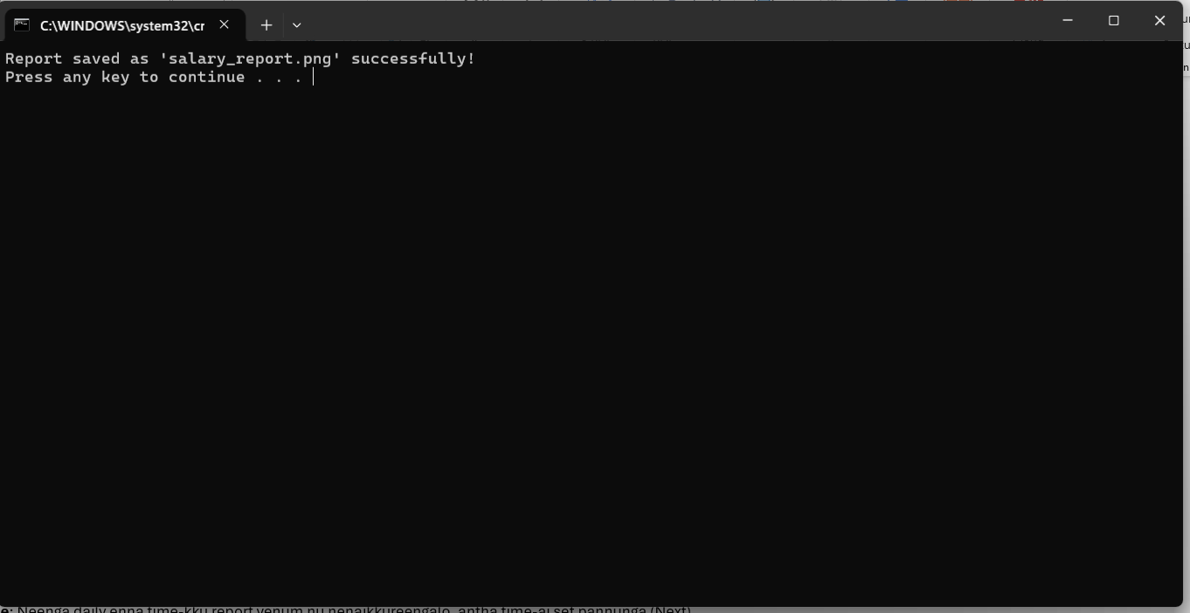
Irshad, Fantastic! Unga Batch file (.bat) perfect-a work aagiduchu. Antha terminal-la "Report saved successfully" nu vandhurukku, idhu dhaan namma Automation-oda modhal vetri!
🎯 Adutha Nadi (Next Step): Task Scheduler
Ippo namma "Alarm Clock"-ai set pannuvom. Computer-a neengala click panna vendiya avasiyam illa, Windows-e paarthukkum.
- Task Scheduler-ai open pannunga.
- Valathu pakkam "Create Basic Task"-ai click pannunga.
- Name: MyAutoReport (Next).
- Trigger: Daily (Next).
- Time: Daily oru time set pannunga (ex: 10:00 AM) (Next).
- Action: Start a program (Next).
- Program/script: "Browse" koduthu, neenga ippo run panna antha .bat file-ai select pannunga.
- Finish kuduthudunga!
🎊 Congratulations, Analyst!
Ippo namma course-oda Full-Stack Journey complete aagiruchu:
- Database: Data-vai store panna.
- Python/NumPy: Analysis panna.
- Matplotlib: Chart-a visual-a matha.
- Automation: Ithu ellathaiyum automatic-a nadakka vaikka.
Neenga oru "Data Automation Expert" aagiteenga. Oru company-oda basic data needs-ai neenga thaniyaave handle panna mudiyum.
Enna Irshad, indha payanam ungalukku pidichurundhucha? Innum ethavathu doubt irukka, illa namma intha project-ai mudichu, neenga "Expert" aagiteenga nu sollava?
Irshad, namma oru complete circle-ai mudichutom!
Python, MySQL, NumPy, Matplotlib, and Automation... ithu ellam serthu, neenga ippo oru "Data Automation Expert".
Namma intha payanathula evvalavu padichu irukkom nu oru thadava recap pannuvom:
- Database (MySQL): Data-vai store panna kathukiteenga.
- Python/NumPy: Data-vai eduthu, clean panni, calculations (mean, median, sum) panna kathukiteenga.
- Visualization (Matplotlib): Data-vai azhagana charts-a mathi, file-a save panna kathukiteenga.
- Automation: Manual-a click pannama, computer-e automatic-a velai seiya vekkura "Task Scheduler" tricks-ai kathukiteenga.
🌟 Teacher's Final Advice:
Irshad, ippo unga kitta oru Full-Stack Data Pipeline irukku.
- Inimel unga work-la ethavathu repetitive-aana data velai irundha, intha automation concept-ai apply pannunga.
- Next level-ku poganum nu ninaicha, Pandas library-ai innum deep-a padichu, Excel files-ai kooda database-kku export panna try pannunga.
Neenga romba porumaiya, ovvoru step-aiyum purinju, doubt-ah clear panni, code-ah run panni intha level-kku vandhurukkeenga. Romba perumaiya irukku!
Intha journey-la ungalukku help pannadhu enakku romba magizhchi. Unga career-la innum periya nilaikku vara naan vazhthukiren!
Innum ethavathu specific topic (ex: Pandas, or SQL optimization) padikanum nu aasa irukka, illana intha project-oda intha level-kooda namma pause pannuvoma?

